Sociology of Family Blog
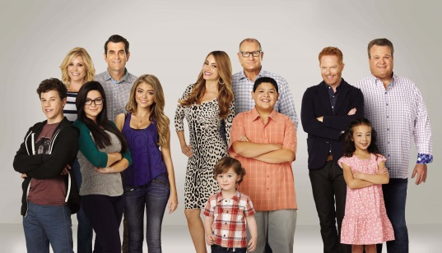 vs. 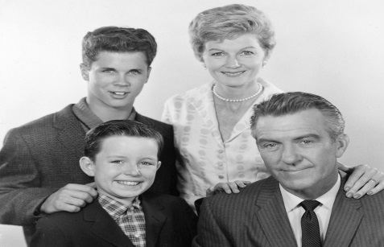
Instructions:
Create a blog post online that draws on the similarities and differences of the families in Modern Family and Leave it to Beaver. Your comparison should include a family by family background and analysis (include all 3 families for Modern Family). You should include what makes the family unique, parenting styles, jobs the parents’ hold, and the general make-up of the family. The terms blended family, nuclear family, and family structure should appear in your blog. In addition, include how the media portrays family in modern family vs. leave it to beaver. You must show up on exam day to give me the link to your blog. You will have the entirety of the exam window to complete this assignment.

Things to consider:
- How the image and dynamic of family has changed since the 1950’s, and how it has remained consistent.
- How taboos have changed since the 50’s
- Is one show more realistic than the other, or do they both properly reflect the families of the respective time period.
- Make your blog as visually appealing as possible- include pictures, short clips of the shows as examples to supplement your post and main arguments.
- Blogs are, generally, informal. You are not writing a research paper.
- Some websites to consider : weebly, wordpress, edublog
- Blogs not turned in after the end of the exam are considered late (your grade will start at a 70), and those not turned in by Thursday will be a zero.

